Inputting Time for Post Docs

*Post-Docs will begin to enter time in TRS with the conversion to UCPATH. PTO and Sick time is the only time that needs to be recorded in TRS.*

1. Sign into TRS ([timesheet.uci.edu](https://timesheet.uci.edu/)), and click on the “Manage My Time” tab
2. Select the time sheet by clicking on the piece of paper under “Action”
3. Click on the paper icon to create a new schedule
4. On the next screen, it will ask if you need to record PTO, select “yes” and it will open the timesheet for the month. Elements of the timesheet are:
   1. Due Date
   2. Reset, which clears the timesheet and takes you back to the screen asking about recording time
   3. Calendar to record time
   4. Balances of time recorded on the timesheet
   5. Save and Submit buttons

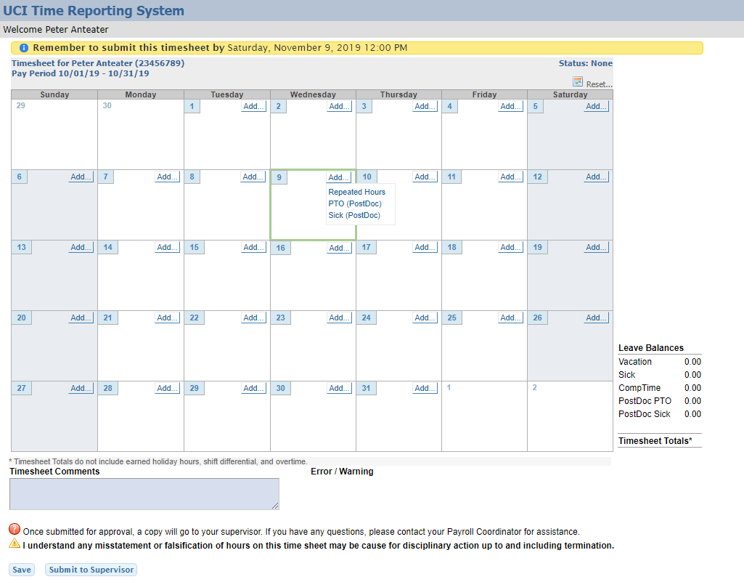

**e**

**d**

**c**

**b**

**a**

1. Select “Add…”, then select the type of hours that are to be recorded for the day.
2. If there is time to record for multiple, consecutive days, “Repeated Hours” can be selected and entered.
   1. Select the type of time to record
   2. the from date and to date
   3. the number of hours per day

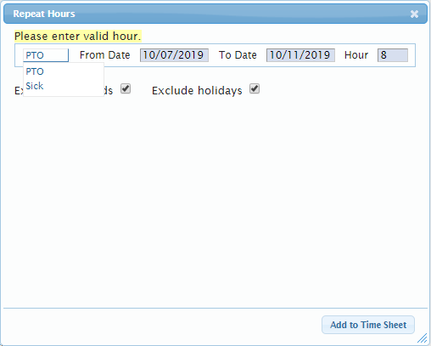

* 1. 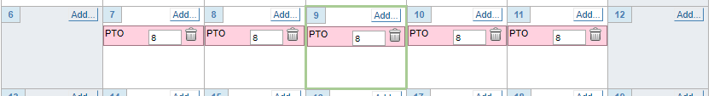the hours will populate on the calendar.

1. If you are tracking hours through the month, you can save the timesheet.
2. When ready to submit the timesheet, select send to supervisor.