This document provides the Agenda Topics per each Training Tips Presentation.
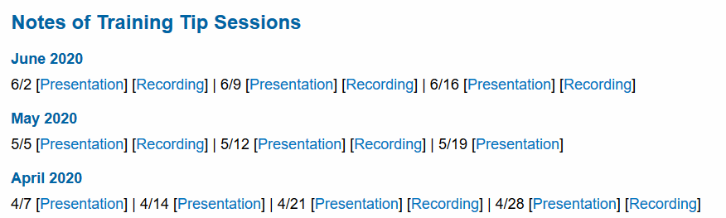
- Find the date of the topic you are interested in, then open the presentation or recording for that date.

April 7
- Job Data Updates
  - Effective Dates
  - Position vs. Job Data Tab
- Appointment Extensions
- Submitting Position Update & Job Data Update forms

April 14
- Extended Absences
  - Returning employees from leave
- TRS Resources
- Payroll Deadline Calendar
- Transferring Position to another Department
- Additional Pay (repeat from 4/7)

April 21
- JED & Extended Absences
  - How by percent & by amounts impact transaction entry
- Position Update Form & Job Data Update Form
  - When should they be used?
  - New Position vs. Correcting Position
- Without Salary (WOS) Appointments
- Academic Post Doc processing

April 28
- Academic Post Doc processing (by Amy Ruth)
- Auto Termination Rules
- Changing Position Title Names

May 5
- Work Study & Using KFS Sub-Accounts
- Extending Appointment End Dates
  - Available Reports to monitor
  - Reinstatements
- Missing Empl Records in Smart HR Templates
- Accrual Adjustments & Vacation Max process

May 12
- COVID-19 Leave Process
  - TRS & UCPath Updates
- Comp Time Payouts
- Budget Distribution Updates
  - Reclassification, Promotions
  - Pay & Merit Increases
- Pre-Conversion Pay for Employees

May 19
- Short Work Break Matrix
  - Policy & Matrix
  - Transaction, Benefits, etc.
- UCPath Roles Wiki (Nasser Khan)
  - Additional Security Information
- Template Transaction User Guide
- Pre-Conversion Pay for Employees
- Post Doc Anniversary Dates reconciliation
- Update on COVID-19 leaves

May 26

June 2
- Funding Corrections
- Changing Pay Frequencies
  - FLSA Changes / Mismatches
- Additional Pay Support
- New Off-Cycle Process

June 9
- Direct Retro Splits – Andrea Garrison
- Grad Student Processing
  - WOS & Paid Appointments
  - Mass Hire pans in Fall
- Short Work Break
  - Job Aids & Other Materials
  - Abeyance
- Summer Salary Quick tips

June 16
- Direct Retro & Work Study
- Changing Salary Admin Plans
- UCPath Grad – WOS Jobs
- UCPC Discrepancies
- Q & A Session with Transactors

June 23
- Terminations & Final Pay
- Direct Retro Reminders
- BYA Salary Admin Plan for WOS
- Above Scale Faculty
- Q & A

June 30
- Vacation Leave Accruals
- Retirement Process Update
- Appointment End Dates
- Short Work Break Benefits Billing
- Summer Salary Updates for July
  - Fixes from work-around
- Bi-Weekly Dates for Additional Pay

July 7
- New Training Schedule
- Summer Salary Distribution
- Auto Terminations
- Summer Salary Management
- Funding Rollover
- Recall vs. Emeritus Appts
- Using the Rehire vs. Reinstatement template

July 14
- Short Work Break and Union Dues
- New Transaction Requirements for BX Employees
- Distributions UCPath vs PPS
- Transferring Positions to another Department

July 21
- Benefit Election Forms
- NSTP
- Additional Pay and SMART HR Templates
  - Do NOT enter additional pay on the SMART HR Template
- Virtual Drop In
  - Please be ready to:
  - Share your screen
  - Employee ID
  - Description of Issue
  - Transaction details
- Finding Reallocation
- Template Transaction User Guide
- Inter-location One-Time Payments
- Know Issues

July 28
- Benefit /Salary Cost Transfers
  - Do Not select multiple checks in one transaction
  - If more than one is selected, this will cause an Error, BUT initiators will NOT get an Error mssg.
- Overpayments - please fill out spreadsheet which was sent
- COGNOS reports are being delayed.

INDEX

Accruals, 2, 3
Additional Pay, 1, 2, 3, 4
Auto Termination, 1
Auto Terminations, 3
Budget Distribution, 2
Comp Time Payouts, 2
Direct Retro, 3
Effective Dates, 1
Extended Absences, 1
Final Pay, 3
Funding, 2, 3
Job End Dat, 1
Job End Dates, 2, 3
Overpayments, 4
Payroll, 1
Post Doc, 1
Post- Doc, 2
Pre-Conversion Pay, 2
Reinstatement, 2, 3
Short Work Break, 2, 3, 4
Summer Salary, 3
Template Transaction User Guide, 2, 4
Transferring, 1
Update Form, 1
Work Study, 2
WOS, 1, 3

